EXPERIMENT 9
CREATING A SCRUM PROJECT WITH BACKLOG AND SPRINT IN JIRA
AIM
To create a Scrum project in Jira, add user stories to the product
PROCEDURE
Step 1: Login
- Open a web browser and navigate to the Jira website.
- Login - https://id.atlassian.com/login
- Sign in to your Jira account using your registered email address and password.
- After successful authentication, access the Jira dashboard to begin the project creation process.
Step 2: Create a Scrum Project
- Click Create Project from the Jira dashboard.
- Select the Scrum project template.
- Enter the project name as Scrum Workflow Project.
- Choose Team-managed as the project type.
- Keep the access level as Open.
- Click Create to create the Scrum project.
Step 3: Create Backlog Items
- Open the Backlog tab in the Scrum project.
- Click Create to add new backlog items.
- Create the following five backlog items:
- Create User Registration Page
- Develop API for Login
- Design Home Page
- Test Login Functionality
- Deploy Application
- Verify that all the created items are displayed in the project backlog.
Step 4: Prioritize the Backlog
- Arrange the backlog items according to their priority by dragging and dropping them.
- Set the highest priority for Create User Registration Page and Develop API for Login.
- Place the remaining tasks in the desired order based on project requirements.
- Verify that the backlog is prioritized correctly.
Step 5: Create a 1-Week Sprint
- Click Create Sprint in the Backlog view.
- Drag all five backlog items into the newly created sprint.
- Set the sprint duration to 1 week by selecting the start and end dates.
- Verify that all selected backlog items are included in the sprint.
Step 6: Start the Sprint
- Click the Start Sprint button.
- Confirm the sprint name and duration.
- Start the sprint to move the selected backlog items into the active sprint.
- Verify that the sprint has started successfully.
Step 7: Sprint Board at the Start
- Open the Active Sprints board.
- Verify that all sprint tasks are displayed in the To Do column.
- Capture a screenshot of the sprint board before moving any tasks.
Step 8: Sprint Board at the End
- Simulate the sprint workflow by moving the tasks across the board:
- Verify that the sprint board displays tasks in To Do, In Progress, and Done columns.
- Capture a final screenshot of the sprint board after the workflow simulation.
OUTPUT
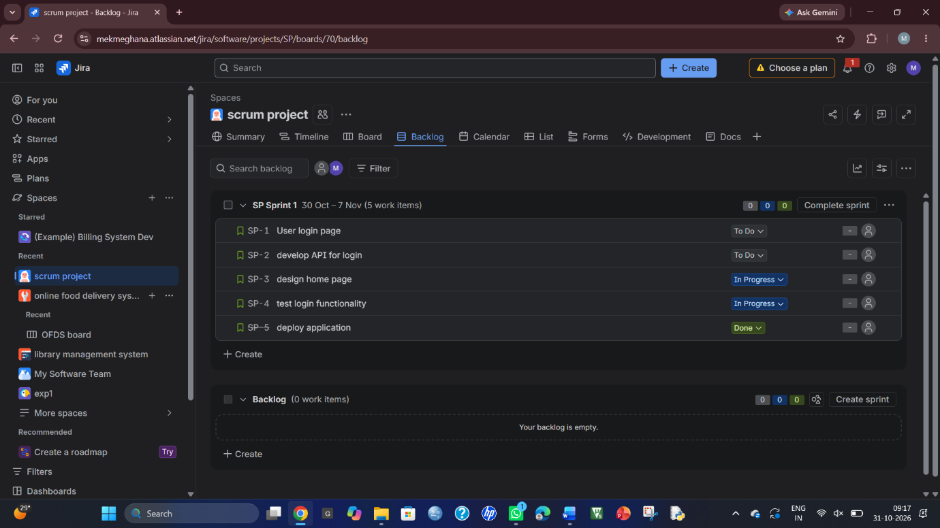
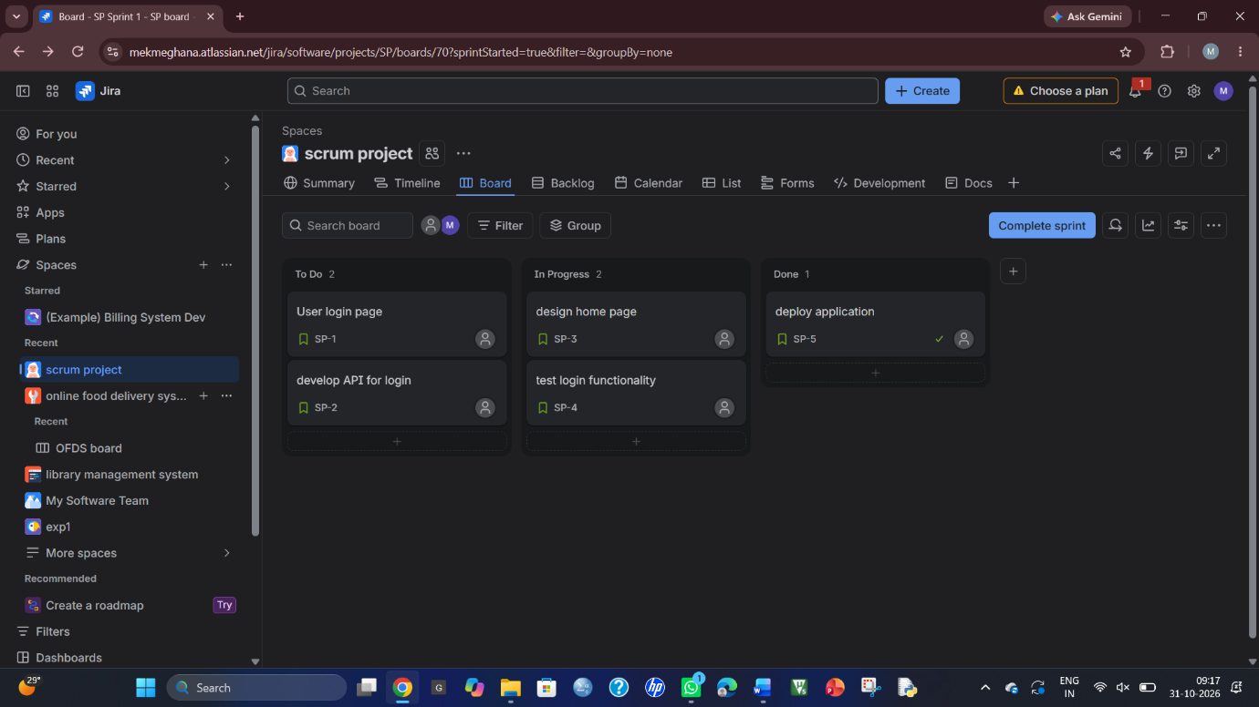
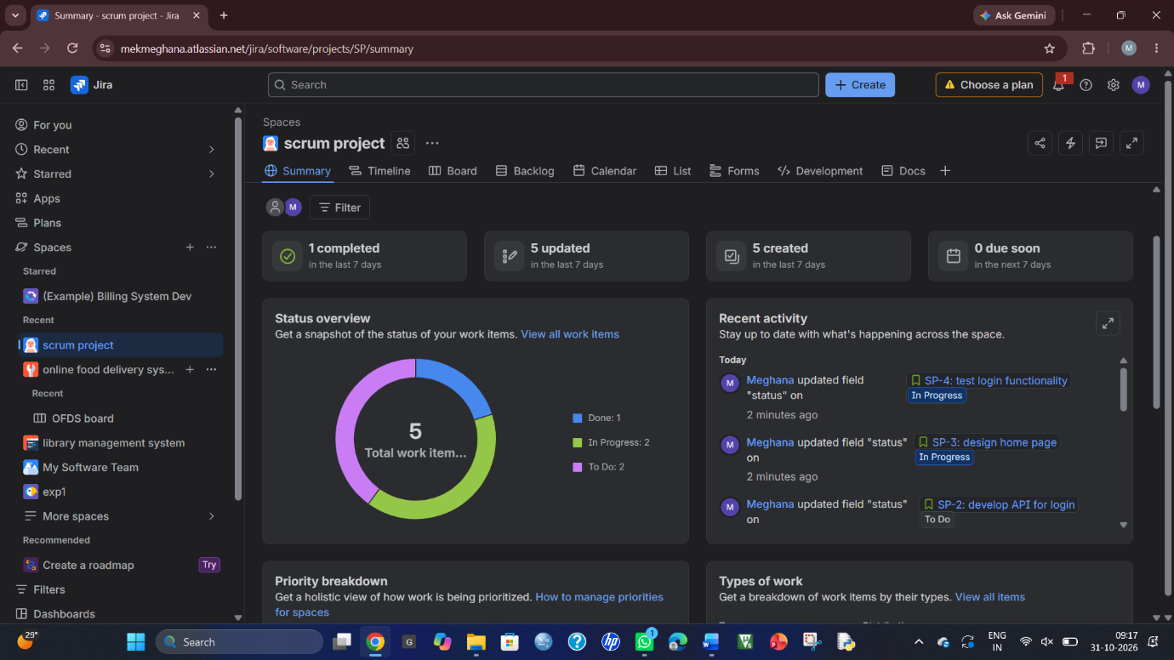
RESULT
Thus a Scrum project was created in Jira, backlog items were added, a sprint was planned and
started, and progress was tracked on the sprint board.

